1. **Filters**

**Extracting filter responses**

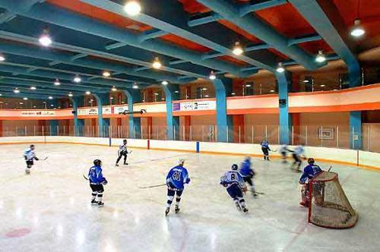

Input image of indoor ice skating

path = ../data/ice_skating/sun_aamerccwdeptadrz.jpg

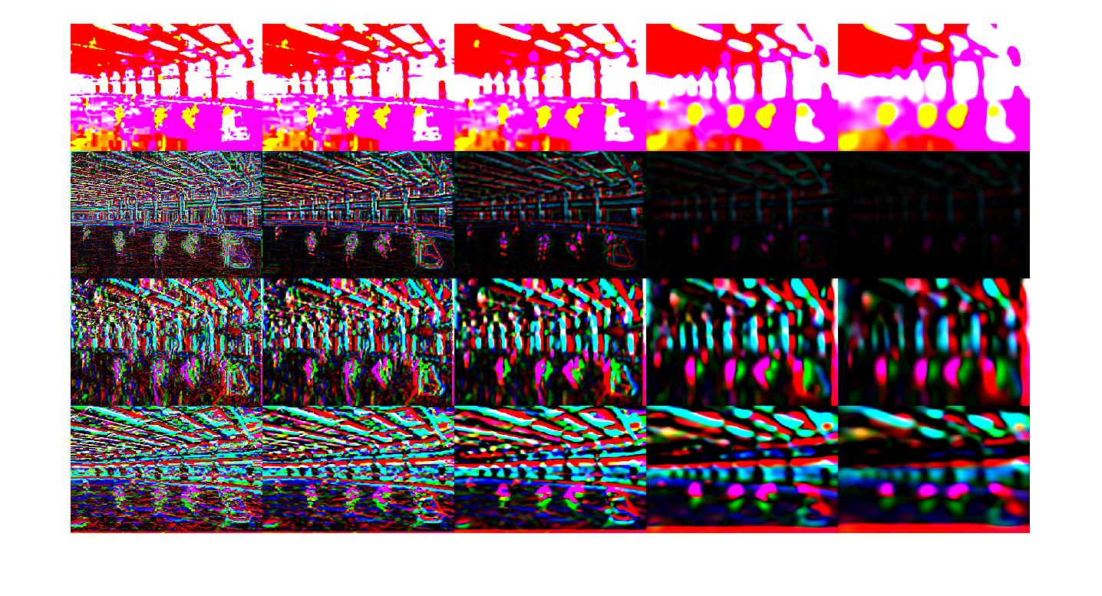Filter Responses of the L*a*b version of the image using the montage function.

**1.3 WordMap Visualization**



RGB image

path = ../data/ice_skating/sun_aamerccwdeptadrz.jpg

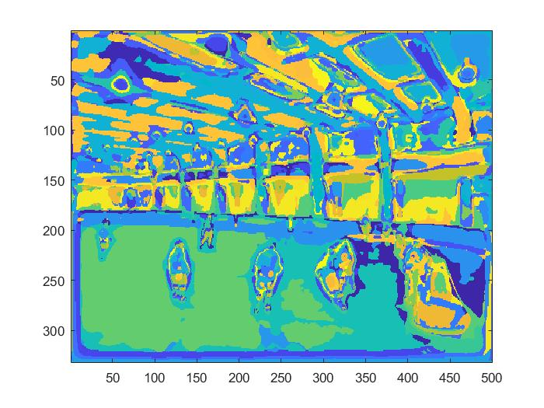

Wordmap visualization using imagesc() function

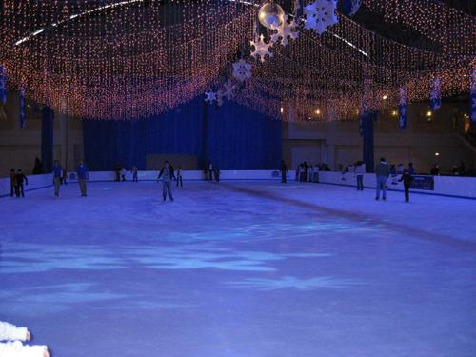

RGB image

path = ../data/ice_skating/sun_absxwroozitnpiwm.jpg

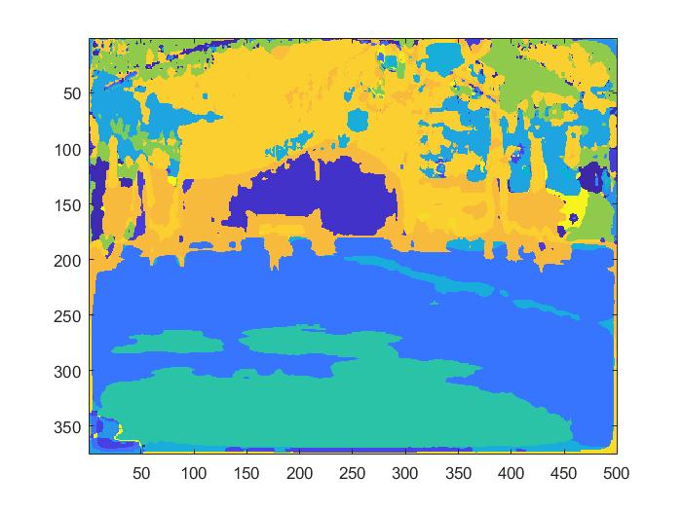

Wordmap visualization using imagesc() function

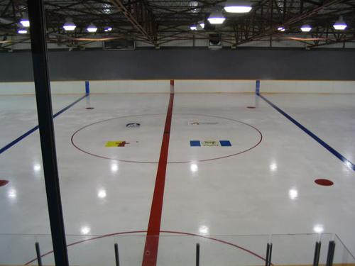

RGB image

path = ../data/ice_skating/ sun_abxvvrflfkhpimek.jpg

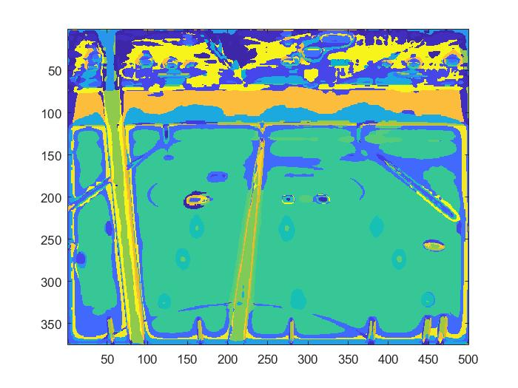

Wordmap visualization using imagesc() function

Comments:

**2.5 Evaluation**

1. Confusion matrix (8 x 8) :

|  |  |  |  |  |  |  |  |
| --- | --- | --- | --- | --- | --- | --- | --- |
| 9 | 1 | 0 | 4 | 4 | 0 | 0 | 2 |
| 1 | 8 | 1 | 3 | 5 | 1 | 0 | 1 |
| 0 | 0 | 19 | 0 | 0 | 1 | 0 | 0 |
| 0 | 1 | 0 | 18 | 0 | 0 | 0 | 1 |
| 3 | 4 | 0 | 3 | 9 | 1 | 0 | 0 |
| 1 | 0 | 3 | 0 | 2 | 8 | 5 | 1 |
| 0 | 1 | 0 | 0 | 3 | 1 | 14 | 1 |
| 1 | 2 | 1 | 3 | 2 | 1 | 2 | 8 |

1. Accuracy = trace (conf) / sum (conf( : ) = 93/160 = **0.58125**

2.6

In the observed confusion matrix, there are some general misclassifications in the testing set however some of them are more prominent than others. One such example is the library vs computer room pair.

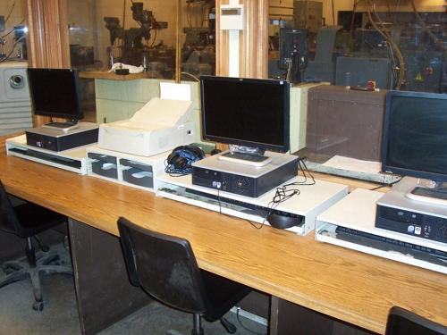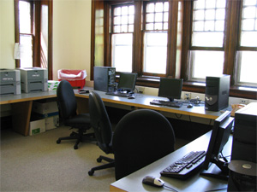

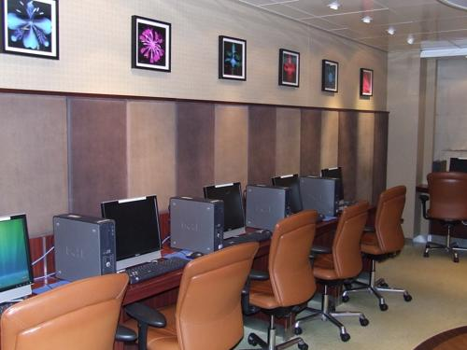 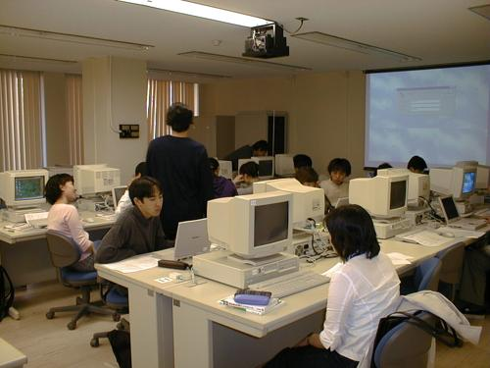

Some Computer Rooms wrongly classified as library

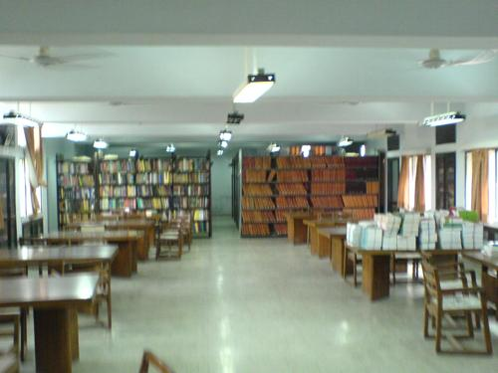 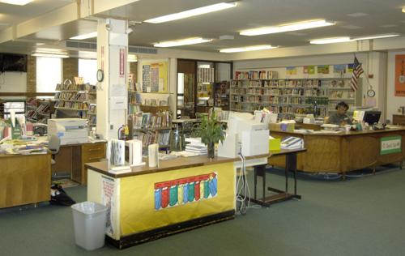

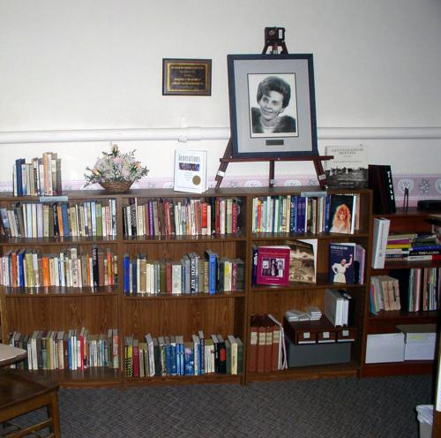 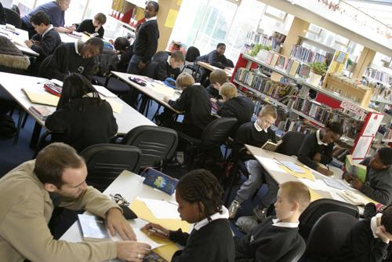

Some libraries wrongly classified as computer room

Since the libraries and computer rooms have a lot of things in common like desks, chairs, indoor lighting conditions and many other features, the model fails to efficiently distinguish between the two classes.

From algorithmic perspective, our algorithm makes comparable histograms in the train_features matrix for both library and computer room images.